**ONLINE E-WASTE COLLECTION SYSTEM**

**ABSTRACT**

Online E-Waste Collection System is used for the collection of the electronic waste material from the customer, local collector, so on.Online E-Waste Collection System is to provide another way for the customer to giving the e-waste material.The customer can define the details about which type of waste is having. The customer can get the money by giving the waste material.It is an Internet based application that can be accessed throughout the Net and can be accessed by anyone who has a net connection.It is an automatic system, where we will automate the free disposal of waste, selling the waste material and enquiries about which wasteequipment are collection. One of the best features of the system is to deploy or recycling the electrical and electronic equipmentfrom the customer house and the city.

**INTRODUCTION**

The tremendous increase in the population of the country has led to improper waste management in cities which results in increased pests and spreading of very harmful and diseases across the regions. Though proper measures are being taken to avoid wastage at the production level in industries, but the waste generated from using such goods are not disposed of properly. People are unaware of the issues caused by their careless waste disposals. They affect animals, aquatic creatures, environment and ultimately contributing to climate change. Thus, the project proposes an online e-waste collection systemthat will help people on how to dispose of various kinds of waste and also tracks the amount of waste produced by each home and region. These data will help the respective authorities to take necessary actions to reduce waste generation.

Electronic items can be classified as Desktops, PDAs, consoles,TVs, Mobile phones and many more. Majority of the people own desktops or PCs and almost 3 of10 people supersede them in a year or two. It is a hazardous fact that about 50 million tonne of E-waste was generated in the year, larger portion of which included personal devices such assmart phones and PCs while rest consisted of heavy household appliances and other equipment’s.Another aspect of this to look at is that only 20%of this waste is recycled each year and the restis either dumped in a landfill, burned or illegallytraded. It is essential for people to look upon theconsequences of E-waste being produced on a large scale and should try to act upon ways ofrecycle and reuse of electronic equipment’s.

**EXISTING SYSTEM**

Electronic waste (E-waste) is an additional barrier to the environment as electronic products contain materials that arehazardous, it poses a threat to human health as several components like computers, televisions, electric lamps, bulbs, batteriesand many others which are disposed illegitimately may release lead and other toxic substances to surface of land leading tolose fertility of soil as well as ground water.

**The problem of e-waste arises**

* Due to lack of knowledge in disposing electronic products,
* The waste collection system is offline
* The electronic and electric waste are deployed and recycling is less than 30%

**PROPOSED SYSTEM**

The online e-waste collection system provides an efficient portal for monitoring, collection, and disposal of wastes from each house and locality. Moreover, the data helps the authorities to take necessary actions.

* To provide anytime anyplace service for the customer
* To reuse electronic waste material by recycling or deploy
* To decrease the electronic waste material from household
* To obtain statistic information about the problems effect by the e-waste material
* To provide awareness about electrical and electronic material using for household

**USECASE DIAGRAM**

use case diagram is a graphical depiction of a user's possible interactions with a system. A use case diagram shows various use cases and different types of users the system has and will often be accompanied by other types of diagrams as well.

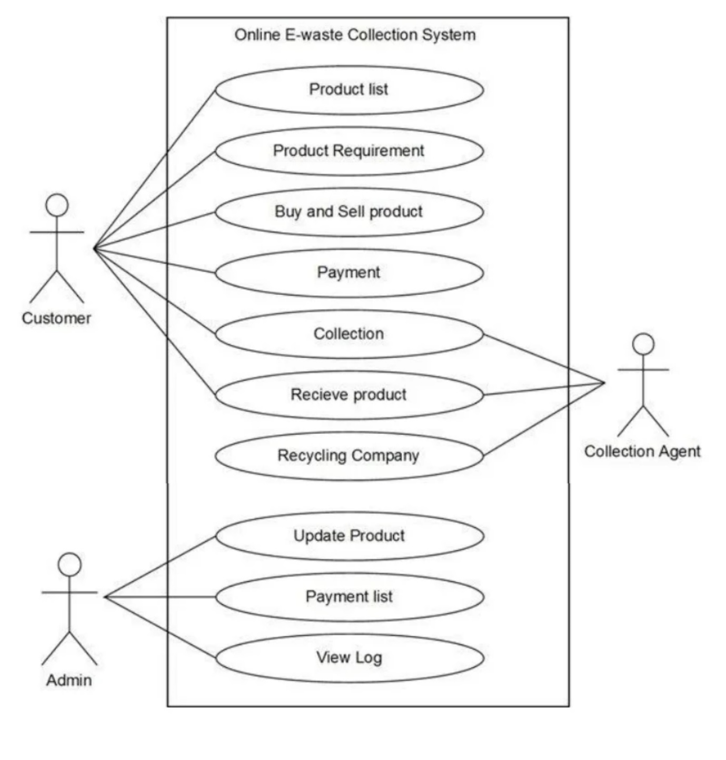

**REQUIREMENT SPECIFICATION**

# System Configuration

**Hardware Requirements:**

Processor : Pentium IV

Hard Disk : 80GB or More

RAM : 4GB or more

**Software Requirements:**

Operating System : Windows 7/8/10/11

User Interface : HTML / JSP, CSS

Client-side Scripting : JavaScript

Programming Language : JAVA

Framework : Spring Boot

Database : MYSQL / MongoDB

**CONCLUSION**

Electronic and electrical equipment's cannot be avoided in today's world. So also, is the case of waste electronics andelectrical equipment. As long as this is a necessary evil, it has to be best managed to minimize it adverse impacts on environment. Electronics waste piles are growing, as is their pollution potential. Most of these problems have their source in the development anddesign of the products concerned. Using this type of system, we can conclude that using the methodology of reduce, reuse and recycledecrease the piles of electronic and electrical equipment, and make environment to be cleaned ad healthy.

**REFERENCE**

* Text Books

1.Java Complete Reference Guide

2.Html

3.Spring Boot Up and Running

* Link

1.www.wikipedia.com

2.www.javatutorialspot.com

3.www.geeksforgeeks.com